Tree of Codes
‘Cut-outs in time’, an opera

Liza Lim

Liza Lim
Tree of Codes (2013-15)
‘Cut-outs in time’, an opera
An opera about bloodlines and memory, time, erasure and illumination based on Jonathan Safran Foer’s Tree of Codes
and Bruno Schulz’ Street of Crocodiles

for soprano, high baritone, singer/clarinettist, fifteen other musicians (also vocalising), electronics + theatre performers

Opera commissioned by Oper Köln, Ensemble musikFabrik and HELLERAU – Europäisches Zentrum der Künste,
Dresden and in co-operation with the Akademie der Künste der Welt Cologne.

Research and development for the electronics part was generously supported by ZKM – Centre for Media and Art, FHNW Musik Akademie Basel. Both this work and creative development to facilitate the completion of the opera were supported through a Senior Creative Fellowship from the Australia Council for the Arts.

Premiere, 9 April 2016, Staatenhaus, Cologne (Also, 12,14,18,10 April)
Also, 25 October 2016, TONLAGEN Festival, Hellerau, Dresden

Composer & librettist: Liza Lim
Libretto based upon Tree of Codes written by Jonathan Safran Foer © first published 2010 by Visual Editions;
Bruno Schulz’ Street of Crocodiles, English translation by Celina Wieniewska; Johann Wolfgang von Goethe’s Erlkönig
and the writings of Michel Foucault.

Director Massimo Furlan
Conductor Clement Power

Cast Singing parts
Adela, soprano Emily Hindrichs
Son/Doctor, high baritone with strong falsetto Christian Miedl
Mutant Bird Carl Rosman
The Crowd actors and musicians
Acting parts
Father Yael Rion
Octopus/ Touya, the ‘idiot-girl’ Diane Decker
Adela double Anne Delahaye
Son double Stéphane Vecchione

Ensemble musikFabrik
Flute/Piccolo/Bass Flute Helen Bledsoe
Flute/Piccolo/Subcontrabass Flute Liz Hirst
Oboe/Cor anglais Peter Veale
Clarinet/Bass clarinet Carl Rosman (also plays the singing part of the Mutant Bird)
Bassoon Lorelei Dowling
Horn (double bell) Christine Chapman
Trumpet (double bell) Marco Blaauw
Trombone (double bell) Bruce Collings
Euphonium (double bell) Melvyn Poore
Percussion Dirk Rothbrust
Piano/Toy Piano/Shruti Box/Kalimba Benjamin Kobler
Violin Juditha Haeberlin
Violin Hannah Weirich
Viola/Strohviol Axel Porath
Violoncello Dirk Wietheger
Double Bass Florentin Ginot

All musicians vocalise and some also use wacky whistles and play percussion

Sound design Paul Jeukendrup

Dramaturg Claire de Ribaupierre
Light designer, assistant director Antoine Friderici
Masks and Make up Julie Monot
Costumes Séverine Besson
Video director Bastien Genoux

Theatre Performers Numero 23 Prod. (see cast list as above)

Duration: 70-75 minutes approx.

Contents

Background iv

Details of Instrumentation v

Performance Notes vi

Recordings, Electronics, Audio-Visual vii

Libretto x

Act I An enormous last day of life 1

Act II The Comet 45

Act III The Ventriloquist 119

Act IV The Tree of Codes 156

Background (L. Lim)

Tree of Codes takes place during an extra day grafted on to the continuity of life. Within this margin of secret time, a ‘backstage’ area, the boundaries between the natural world, animals, birds, humans and machines are dissolving. Dead matter is combined with the living and becomes animated. It learns to dream, to speak, to sing…

A bird mimics language and humans sing like birds. Father…does he know he’s dead?...conjurs birds made out of rubbish into mutant forms of being, recuperating strange life across a boundary of death. There is a kaleidescope of relationships joined by ventriloquism – one thing speaks for another – this world is made up of contingent parts where form is an excuse for slippage. Scene 3: ‘Ventriloquism’, begins with a comet, its sounds recorded by the Rosetta space mission, whilst far, far below, perhaps affected by some strange gravitational pull, a brass band blurts into life. The bubbling, percussive song of the comet is mirrored in a chorus of frogs and insects, Father’s generatio aequivoca which he had dreamed up’ - not real frogs and insects but ‘a kind of pseudofauna and pseudoflora, the result of a fantastic fermentation of matter.’ Musicians play the most primitive of violins in the form of blocks of wood that are bowed with sticks to sound out this pseudo animal kingdom yet, out of this, emerge rhythmic patterns that recite Goethe’s Erlkönig.

Displacement and dissociation of time, space and identity create effects of menace and wonder. What is authentic? What is fake? The opera Tree of Codes asks: ‘how do the inheritances of our genes, our stories and the unconscious beliefs passed down through generations, shape who we are, our desires, our curses? Do the living and dead exist in a relationship of ventriloquism?’ As Bruno Schulz says: ‘What is a Spring dusk? A multitude of unfinished stories. Here are the great breeding grounds of history. The tree roots want to speak…memories awake…’

Synopsis (draft notes by Claire de Ribaupierre)

The Tree of Codes project is based on the book by American author Jonathan Safran Foer, which was itself built upon Bruno Schultz’s collection of short stories, Street of Crocodiles. The Polish writer’s short stories provide the material for the images that we will create: it is the material from which we will draw the characters and their personality, and the scenes. As for Safran Foer’s book, its form is of particular interest, as it focuses on the void, the emptiness, and disappearance. The book’s narrative is built upon another book, ‘behind its back’ so to speak, as Safran Foer cuts up, selects and deletes sentences, while also uncovering hidden and subconscious meanings. Such is the material we decided to work with, with our own artistic license to make choices, remove, add or interpret the words.

We refer to Schulz’s short stories, but also tell a story with our own images and music. Our project tells the story of a child in awe of his father – whom he sees as an almighty hero – as he sees his rise, the success he achieves, and his subsequent fall. In the end, he finds himself in his father’s shoes, like an heir to the story.

Parallel to the story of the son and his father, further issues are dealt with, such as the fading boundaries between the mineral, vegetable and animal (and human) kingdoms, the confusion of past, present and future times, the permeability of reality and fiction. Ultimately, this is a story about ghosts and disappearance, desire and seduction, rising and falling, childhood and aging, and about fantasy and confusion.

The story begins with the intimation of a time and place that are both original and apocalyptic: fertile soils and magma, in which human characters and animals speak an identical language and blend together. Time stands still, enabling the narrative to move forwards in several directions, opening many possible paths. The identity and opposition principles don’t apply anymore: objects are what they are and something more, a woman is both a desirable figure and a repulsive animal, the son blends in with the father, and the father with the bird. The last picture comes back to the first one and the loop comes full circle: the son takes his father’s place.

Details of Instrumentation
The following instrumentation was developed in close collaboration with the musicians of Ensemble musikFabrik, in particular the use of the double-bell instruments.

Flute 1, Piccolo, Bass Flute
Flute 2, Piccolo, Subcontrabass Flute
Oboe, Cor anglais
Clarinet, Bass clarinet [in the first production, this performer also sings/acts the part of the ‘Mutant Bird’]
Bassoon

All the brass instruments are ‘double-bell’ instruments facilitating fast mute changes and in the case of the trumpet, the sounding of a toy instrument attached to one of the bell outlets:
Horn [straight mute, wa wa/ bass trombone harmon mute]
Trumpet [straight mute, wawa; toy trumpet bell attachment also needed]
Trombone [straight, harmon mute]
Euphonium [straight mute, cup mute]

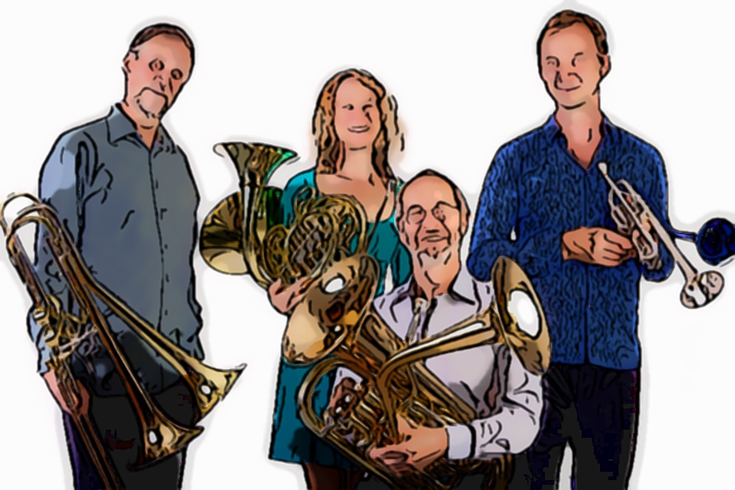
Deep sounding long guiro
3 Temple Blocks
3 Wood Blocks (including 1 made of plastic bowed with rasp stick)
Ratchet
Pair of Rattles: bundle of wooden pods; metal jingles or bells
Pair of maracas
Police whistle
Pistol (toy cap gun – should be loud)
Vuvuzela (Brazilian football horn)
Rainstick (long)
Cuíca
Windwands (1 single, 1 double: http://www.larkinam.com/Roar.html)
Small string drum
Spring coil drum
Vibraphone
Extra metal tube to extend Vibraphone keyboard (F3/4sharp)
Percussion:
‘Drum kit’ comprising:
High ride cymbal
Hi-hat cymbals (foot controlled)
3 tom-toms (small, medium, large)
Bass drum (with pedal) – also played with jingles

Keyboards: Out-of-tune upright piano
Toy piano (amplified & also with ring modulation effect) Shruti box (1 octave, in C)
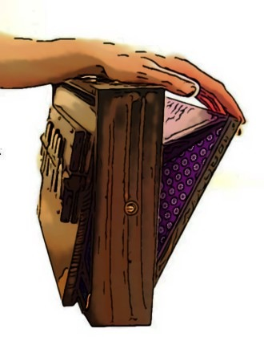
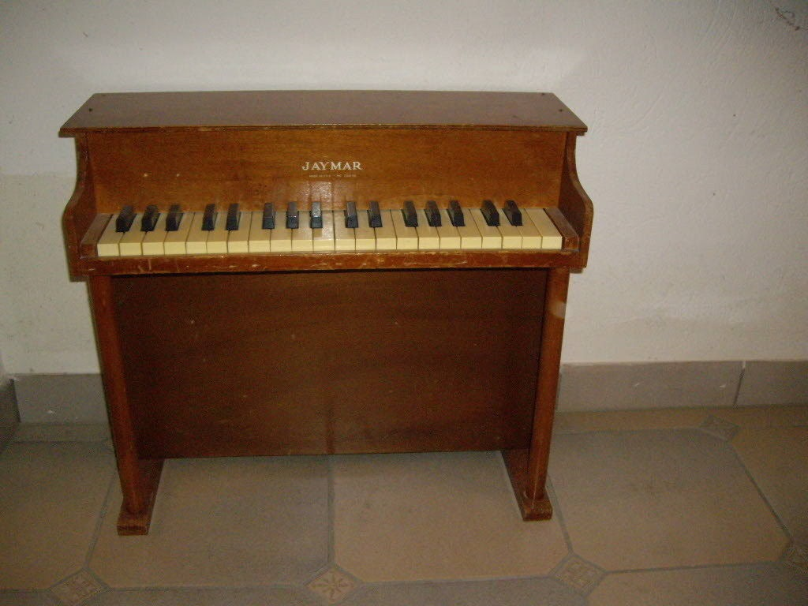

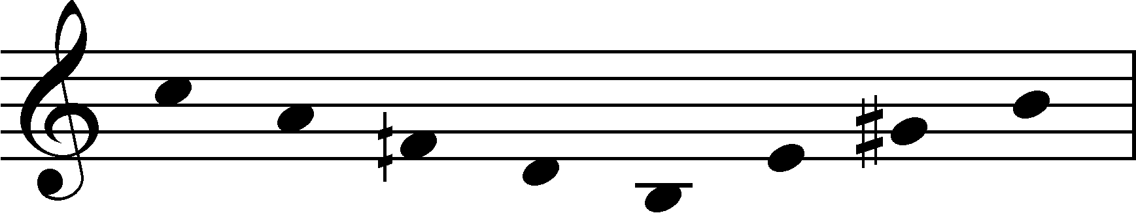
Small Kalimba with resonator, tuned as follows:

Violin 1
Violin 2
Viola, Strohviol
Violoncello
Double bass

All musicians/actors also vocalise, play bird/whacky whistles and percussion including:
5 Temple Blocks (with beater) and 5 Wood Blocks (with rasp sticks) are played by the wind players
A variety of toy wind instruments (eg: Toy Trumpet, Slide Whistle, Kazoo) and bird call whistles are also needed (see Act 4)

Performance Notes

Subcontrabass Flute

Fingerings for multiphonics and microtonal pitches were developed by flautist Liz Hirst (see part for details)

Bassoon

A section of the bassoon part in Act 3 ‘a boat song’, is based on the solo work Axis Mundi (2013). This work was commissioned by Ensemble musikFabrik through the Ministry of Culture NRW. It was written for and dedicated to Alban Wesly with whom I collaborated to develop the techniques and notational approaches used in the score.

In general, the sonic landscape of the piece should be very fluid and dynamic, emphasising differences in colour and texture so that attention is on changing energy states rather than discrete ‘notes’.

The score uses several notational systems within a traditional stave:

1. Single ‘normal’ note-heads indicate sounding pitch

2. A tablature notation is used where diamond note-heads indicate a normal fingering which is altered by venting and sometimes adding another key (indicated by letter names written above the stave). Most of the fingerings of this kind are alternate ‘bisbigliando’ fingerings with a hole open below a notional reference pitch (not indicated in score). The piece works with these ‘scales’ of timbrally diverse microtonal pitches as well as with a variety of multiphonics. These differences in colour and texture should be emphasised particularly with the notes marked with an ‘M’ on the stem. By way of example, the ‘scale’ associated with the venting of the C hole (and associated with the pitch D) is as follows. The use of a Heckel crook or another model of crook which emphasises the higher overtones is necessary to bring out these colour variations (there will be slight variations in result from instrument to instrument).

Very rich multiphonics are produced through this approach and graphic notation is used to indicate an exploration of different regions of the sound. A note-head in square brackets indicates the pitch that should be sounded (usually the top note of the multiphonic); a transition from full multiphonic to single note is indicated with an arrow. Multiphonic effects are also produced using standard fingerings but employing weak air and lip pressure (as discussed by Pascal Gallois in ‘Techniques of Bassoon Playing’ (Bärenreiter, 2009). In the score these are notated either simply with an ‘M’ on the stem or above the stave if the instruction applies to a stream of notes; in some cases, the resulting pitches are shown in bracket.

Brass

All the brass instruments are ‘double-bell’; they have two bells between which the player can switch thus facilitating rapid shifts between open and muted sounds. The following mutes/attachments are needed:

Trumpet – straight mute, wa-wa, toy trumpet bell
Horn – straight mute, wa-wa (eg: bass trombone harmon mute)
Trombone – straight mute, harmon
Euphonium – straight mute, cup mute

The double-bell euphonium solo section in Act 2 is partly derived from the work The Green Lion Eats the Sun (2014) which was commissioned by musikFabrik with the assistance of Stiftung NRW. The work was written for and dedicated to Melvyn Poore.

Keyboards

The Toy Piano will need to be amplified and in Act 1, requires ring modulation effect electronics

Strings

h.sul pont – vary bow position relative to bridge, bow pressure and speed to bring out many different harmonics; vibrato can be used to enhance the vibrancy of the sound.

Quasi multiphonic sounds (notes notated with ‘M’ on the stem) are produced using ‘harmonic’ left hand pressure at non-harmonic nodes. This will result in complex and other airy/noisy results of indistinct or unfocussed pitch. The player should try and get ‘inside’ these sounds, calibrating bow speed and pressure to emphasise their fluctuating, colourful and ambiguous qualities.

Recordings, Electronics, Audio-Visual

Field recording sources
1. Birds & environmental sounds
The electronic sounds found throughout the work are mainly derived from field recordings of Australian birds and other environmental sounds that were generously made available to me by the composer David Lumsdaine. He kindly shared the following information about documentation sources, dates and locations of the recordings with a short description of the soundscape:

WSLCD | Recorded | Locality | Description
1984.10.5-27 | 19/3/1985, 10:15  Sennheiser 816s | Just north of Bouddi NP,  east of Little Beach, NSW | Typical calls of large group of Bell Miners  (Manorina melanophrys) singing inside  forest canopy.
1986.08-13 | 31/8/1986, 06:45  Sennheiser 816s | Vicky’s place, near Bega, NSW | 4 Bell Miners twittering around me,  quite as curious as aggressive. Open eucalypts.
1987.09.2-17 | 22/9/1987, 05:55  Sennheiser 816s | Sharpe’s Creek,  Barrington Tops NP, NSW | Large group of Bell Miners in eucalypts on  hillside. Moisture drips on leaves.  Whipbirds, Magpies & Lewin’s honeyeater etc.
1995.09.1-1 | 7/9/1995, 16:09  Telinga | Old Bucketty Rd,  Yengo NP, NSW | Smallish colony of Bell Miners singing high up  in tall eucalypts by creek.

Additional sounds of wind and trail bikes were obtained from open source materials (Logic library).
The ‘choral’ sounds were derived from segments of the magpie recordings.

2. The comet

Act 3 opens with the sound of a ‘comet song’, the sounds of Comet 67P/Churyumov-Gerasimenko as recorded by the European Space Agency’s Rosetta Plasma Consortium. See https://soundcloud.com/esaops/a-singing-comet and wp.me/p46DHN-Li.

The comet’s ‘song’ is a transposition of oscillations in the magnetic field in the comet’s environment occurring at 40-50 millihertz. This is at a vibrational range far below human hearing which typically picks up sound between 20 Hz and 20 kHz. These very low frequencies have been increased to make the sounds audible to the human ear and the sonification of the RPC-Mag data was compiled by German composer Manuel Senfft (www.tagirijus.de).

Copyright Notice
Original Data Credit: ESA/Rosetta/RPC/RPC-MAG
Sonification: TU Braunschweig/IGEP/Manuel Senfft, CC-BY-NC-SA 4.0 creativecommons.org/licenses/by-nc-sa/4.0/

3. Heart beat

Act 4 begins with a subliminal ‘heart beat’ created with a very low frequency transposition to 43 Hz of the Bell Miner bird sound.

Electronics
An electronic soundtrack is used at several points in the work, elements of which are also triggered live via iPad by the Mutant Bird character. The iPad instrument takes the form of an image snapshot of a page from the Jonathan Safran Foer book, individual words and phrases acting as controls for pre-recorded sounds.

Apple iPad controls plan for soundscape

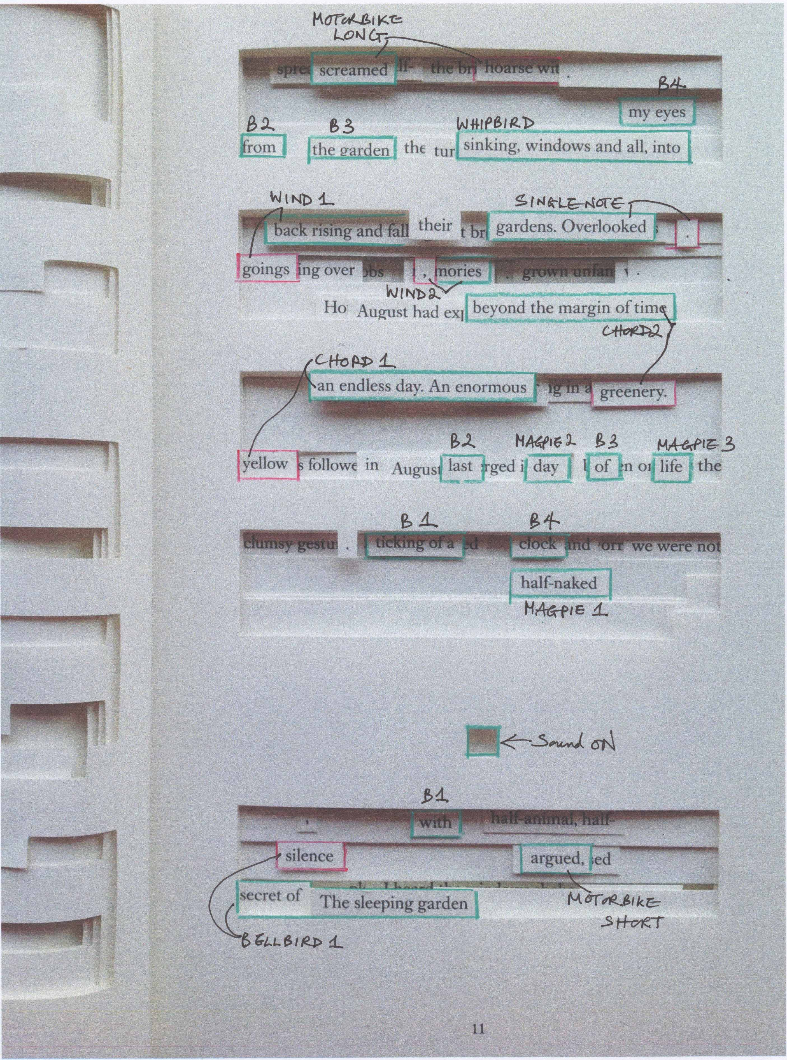

Audio-visual element

The elements of the recorded soundscape are also the basis for an audio-visual component used at the start of the work.

The tracks ‘bell-bird 1’ and ‘magpies’ are slowed down and performed by a number of players (trumpet, trombone, euphonium, horn + Mutant Bird character). These video recordings are then sped up to match the original tracks so that it appears that each performer is singing the bird songs at pitch.

Amplification and Megaphones

Singers are amplified
A number of megaphones are also used
Singers can also use hand-held microphones for the section: Act 2, bars 105-126 (also see performance notes)

Libretto

Libretto devised by Liza Lim based upon:
Tree of Codes by Jonathan Safran Foer © first published 2010 Visual Editions
Bruno Schulz’ Street of Crocodiles (English translation by Celina Wieniewska)
Johann Wolfgang von Goethe’s Erlkönig and the writings of Michel Foucault

I. An enormous last day of life 15’
the boundaries between animals, humans, machines and the natural world are dissolving

II. The Comet 22’
i. Carnival
crowd of painted masks fill the streets

ii. Father
Father transforms into an octopus and is seduced by Adela
Father creates fantastical mutant birds/ the crowd destroys them
the escape artist

III The Ventriloquist 20’
Sanatorium under the sign of the hourglass
the ballad (part 1)
a boat song
the ballad (part 2)

IV. The Tree of Codes 12’
the secret backstage area

Tree of Codes
‘cut-outs’ in time, an opera

[numbers that appear within the text refer to the page numbers of the Safran Foer; other Shulz texts are referenced by story title]

I. An enormous last day of life
- the boundaries between animals, humans, machines and the natural world are dissolving -

Scene of fertile decay out of which emerges the strange/naked/crazy Father

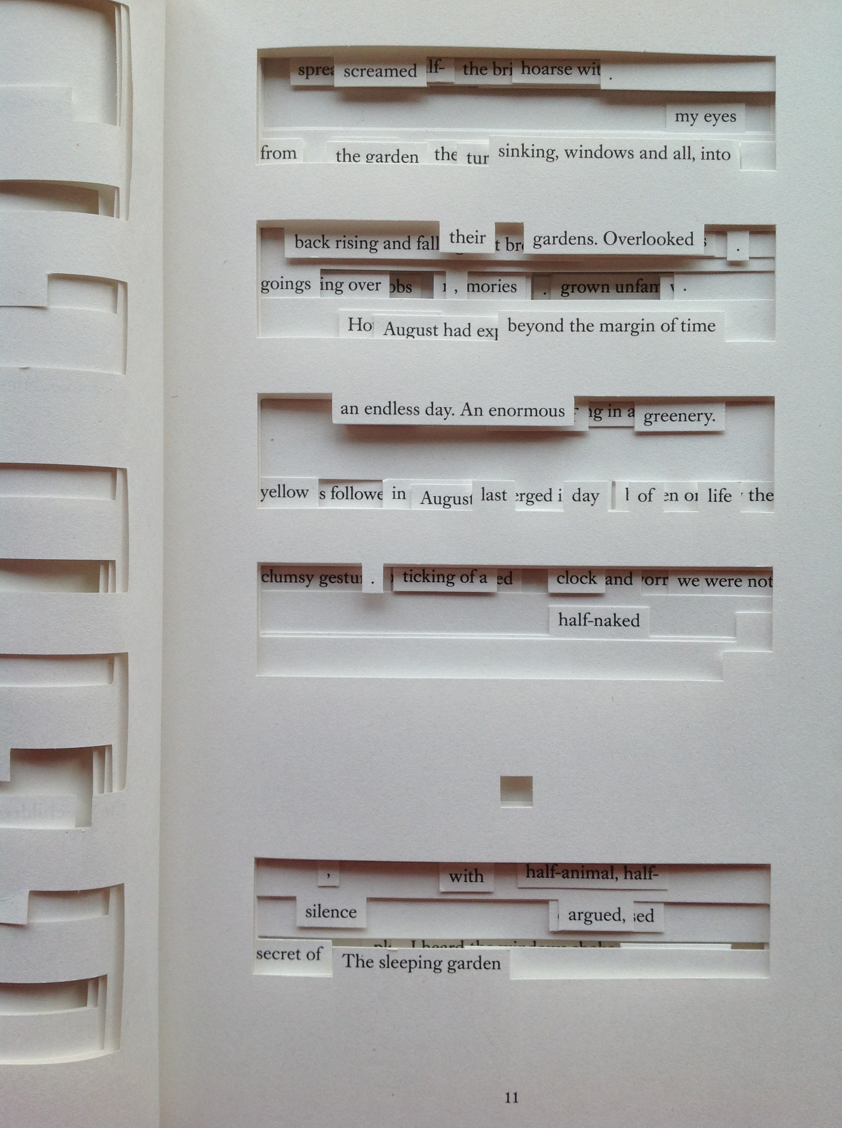

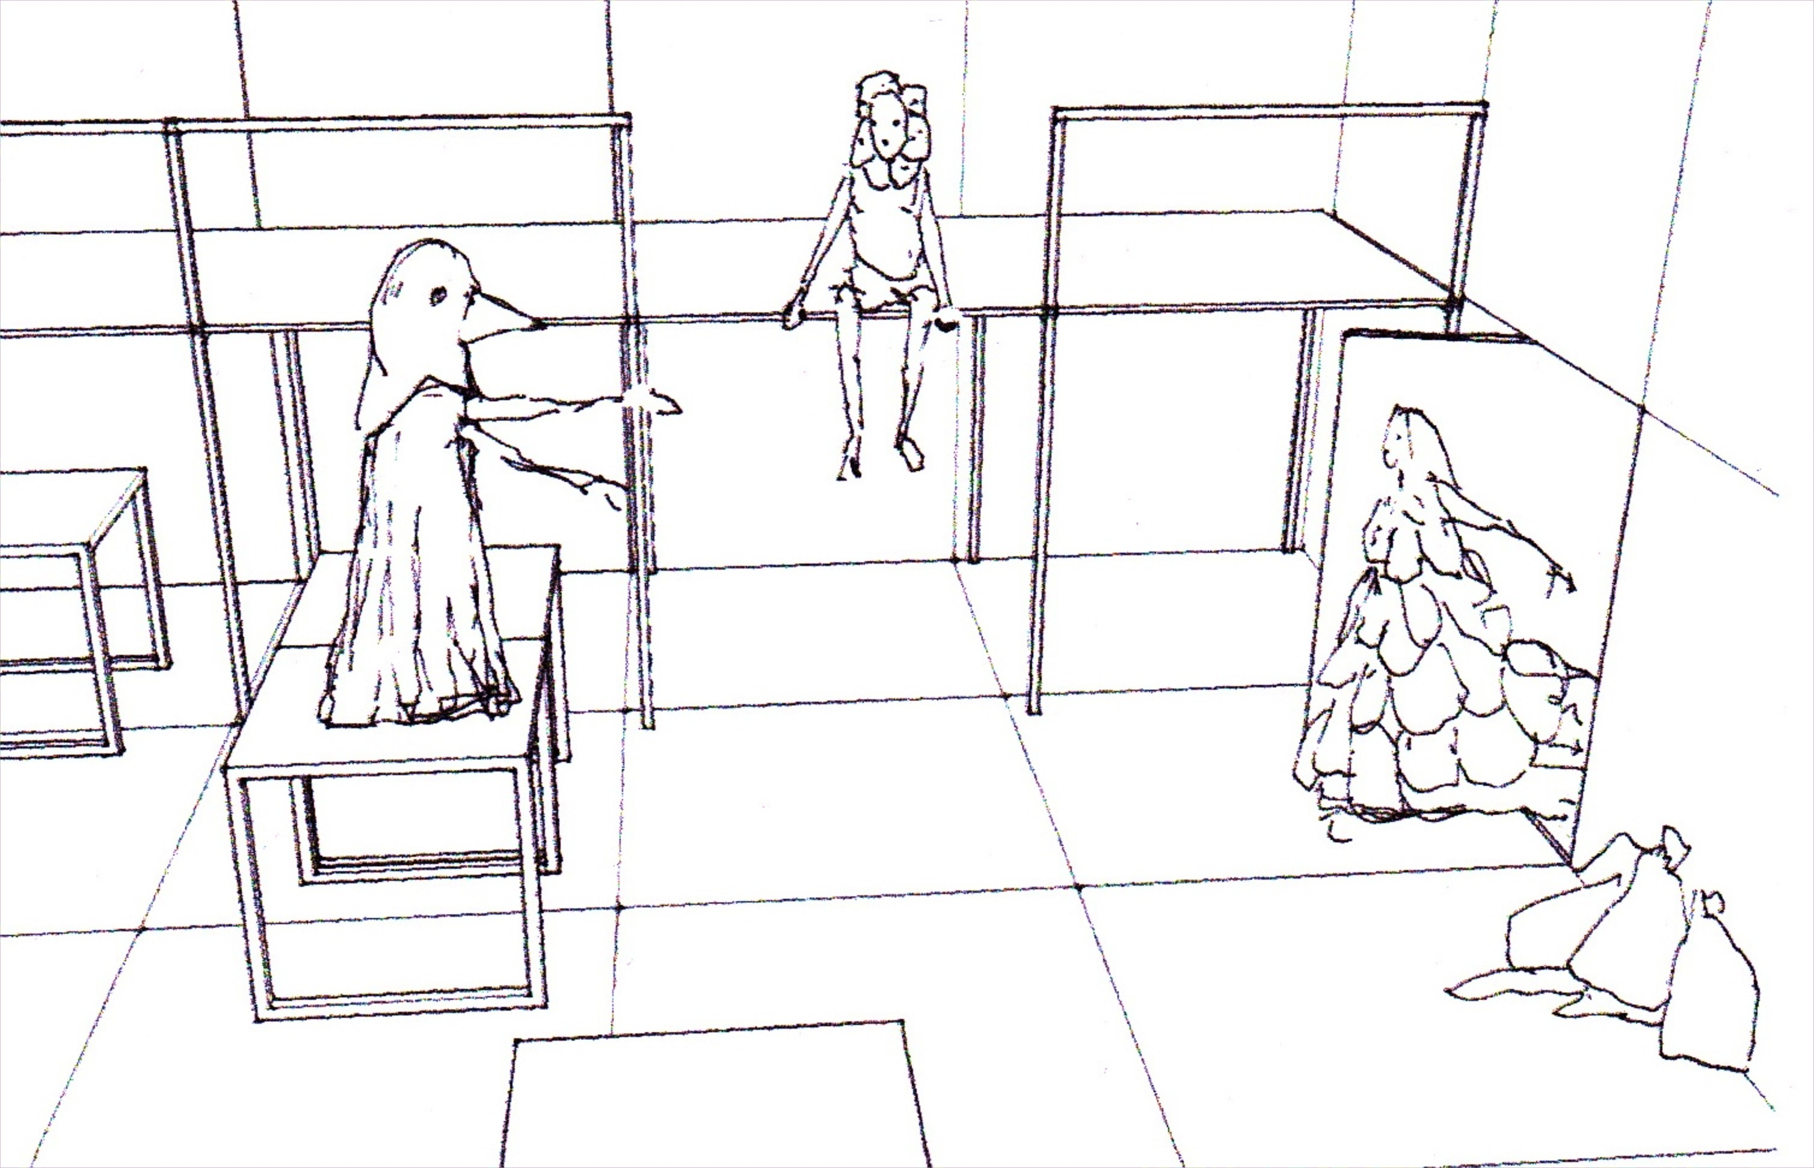
Mythic (mutant) bird: ‘protolanguage’ of bird whistles and rasps becoming language
[Drawing by Massimo Furlan]

Bird + Adela:
Overlooked
beyond the margin of time
an endless day [11]
rising and falling
expanded into tongues of greenery [12]
Adela
I hear the tree roots speak
under the turf
old tales and ancient sagas
a father
a son
I hear underground whispers
dark nameless things

Son (ventriloquism scene – with puppet) [Sanatorium, p.240-242]
Son: Is my father alive?
Puppet: No, he’s dead
Son: Does he guess?
Puppet: No, he doesn’t guess

Son:
No, he doesn’t guess
This is a secret operation
We have put back the clock
It’s simple
Here, he’s alive
No-one guesses
Here we reactivate time past

A map
My father kept a beautiful map of our city
The city rose towards the centre of the map [87]
A tree of codes [88]
Honeycombed with streets unexplored [Street of Crocodiles, p. 69]

Adela
The roots
are the great breeding
grounds of history

A map
Only a few streets were marked [Crocodiles, p.69]
An enormous geometry of emptiness [90]
double meanings [Street, p.71]
dreams multiply
on the borders of an endless day [August, p.17]

The Son approaches Adela

What is this district? [Crocodiles, p.70]
The wrong staircase, unfamiliar balconies
Unexpected doors, strange empty courtyards [22/23]

Bird + Adela
Overlooked by the light of day
An enormous last day of life [11]

a ceaseless turning of pages
a bird’s-eye mirage of a city [111]
The day is still leaving…
The night is yet to come

Adela (to the Father)
Come, take my hand
dip your face into that dusk.
under the lid of a coffin.
push across the dull humus –
You are in the Deep
you can see…

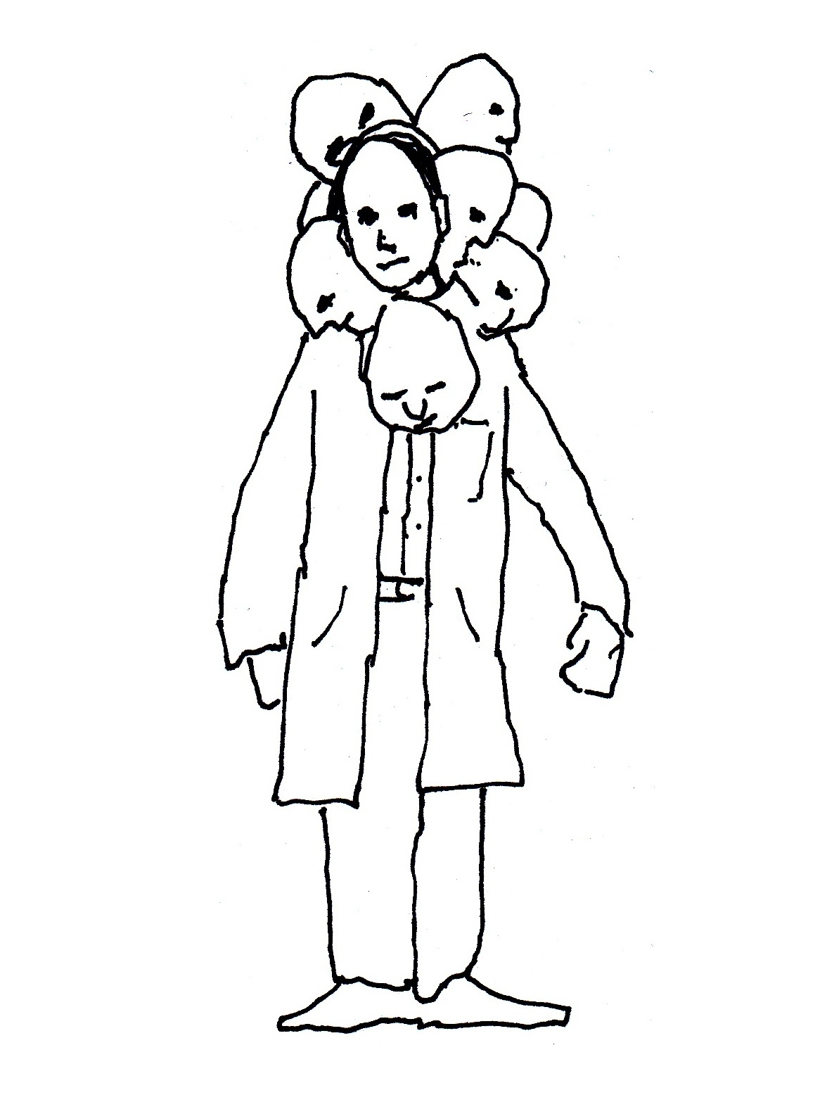

II. The Comet

i. Carnival
- crowd of painted masks fill the streets -

Son
Each night appeared that fatal comet [132]
We were losing our bearings
Moving a finger across maps of the sky
From star to star [The Comet, p.107]
Crowds filled the street, relentless [131]

We wish, We wish,
We want, we want, we want [51]

Adela, a seductive young woman

I taste girls like roses beginning to shed their petals,
the rustle of their underskirts…
the sweetness

I went in silence
through the crowd of painted masks
swelling with pathos
with the tremor of moments of revelation [76]

I see tears like lilac blooms [Spring, Ch 16, p.166]
Pale young men conquered
in forgotten gardens

I found myself lost
Everything was full
Time passed unevenly
Without transition and
full of secret silent moments [80-82]

I smell old wine-barrels
Nameless delight
A backstage tangle of velvet curtains
a distant climax

ii. Father
- Father transforms into an octopus and is seduced by Adela

Son:

Here my father began to set before our eyes the picture of that
generatio aequivoca which he had dreamed up…a kind of
pseudofauna and pseudoflora, the result of a fantastic fermentation of matter.
They were creations resembling, in appearance only, living creatures such as
crustaceans, vertebrates, cephalopods. [Schulz, p.44]

[She closed my mouth with hers and screamed together with me, Age of Genius, p.141]

Touya, the ‘idiot-girl’ is on the rubbish heap [August, pp.17-18]

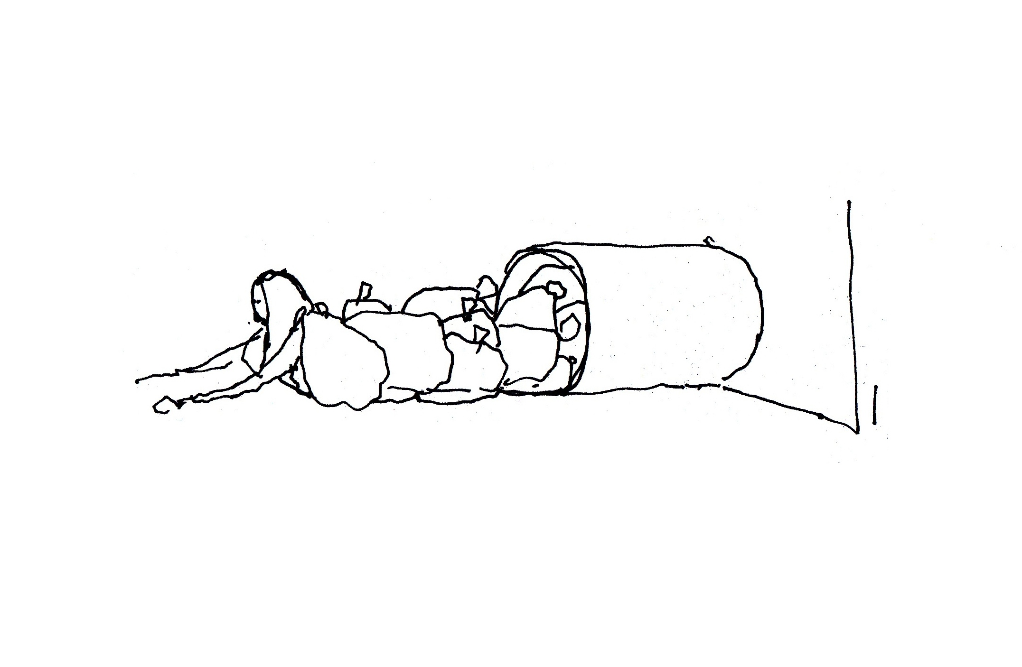

Son: We wish, We wish
We want, we want, we want

- Father creates fantastical mutant birds/ the crowd destroys them -

Father conjures birds out of rubbish

There were among them two-headed birds and birds with many wings,
there were cripples too, limping through the air in one-winged, awkward flight.
The sky now resembled those in old murals, full of monsters and fantastic beasts,
which circled around, passing and eluding each other in elliptical manoeuvres…
But these blind birds made of paper could not recognize my father.
In vain did he call out to them with the old formulas,
in the forgotten language of the birds – they did not hear nor see him.
All of a sudden, stones began to whistle through the air.
The merrymakers, the stupid, thoughtless people had begun
To throw them into the fantastic bird-filled sky.
[The Night of the Great Season, pp.94-96]

Crowd: We wish, We wish
We want, we want, we want

The crowd laughs
at the misery which does not
know what it is and why it is.
The crowd laughs.
Do you understand the sadness of comic genius! [56]

- The escape artist -

Son: Adela:

My father became smaller and smaller,
Knot by knot he loosened himself [34] Knot by knot he loosened himself
He would say: ”how beautiful is forgetting! Knot by knot, a distant climax
What a relief it would be for the world to lose some of its contents!” [48]
He would say: “all attempts are transient and easy to dissolve.
Our creations are temporary” [51]

“We are not,” he said, “long-term beings.
not heroes of romances in many volumes.
for one gesture, for one word alone, we shall make the effort.
We shall have this as our aim: a gesture.
“Can you understand,” asked my father,
“the deep meaning of that weakness?
the proof of our life. We love each gesture.” [51-52]

My father was the only one who knew a secret escape [132-133]
Somewhere at the back gate of the world
His eyes closed. His gaze moved. He saw no comet.
My father alone was awake, wandering silently through the rooms. [133-134]

III. The Ventriloquist

[Sanatorium under the sign of the hourglass, pp. 241-242]

- Sanatorium under the sign of the hourglass -

(male singer with ventriloquist’s puppet)

Son: Doctor (speaks Polish)
Is my father alive?
Żyje, naturalnie
Oczywiście w granicach uwarunkowanych sytuacją.
Yes, he’s alive? Within the limits of the situation?
Wie pan równie dobrze jak ja, że z punktu widzenia
pańskiego domu, z perspektywy pańskiej ojczyzny –
ojciec umarł.
you mean, at home he’s dead but here in this country he’s alive
To się nie da całkiem odrobić.
Ta śmierć rzuca pewien cień na jego tutejszą egzystencję.
His existence has the shadow of death

But does Father himself know it, does he guess?
nie domyśla się?

Niech pan będzie spokojny
Nasi pacjenci nie domyślają się, nie mogą się domyślić.
None of the patients know, no-one guesses
Cały trick polega na tym
że cofnęliśmy czas.
Rzecz sprowadza się do prostego relatywizmu.

Reaktywujemy tu przeszły czas.
The whole secret of the operation
is that they have put back the clock.
It is a matter of simple relativity.

Here we reactivate time past.

Father: lifelessness is only a disguise

We have lived for too long

- the ballad (part 1) -

Adela:

Let me tell you a story:

There were among them two-headed birds and birds with many wings,
there were cripples too, limping through the air in one-winged, awkward flight.
The sky now resembled those in old murals, full of monsters and fantastic beasts,
which circled around, passing and eluding each other in elliptical manoeuvres…
But these blind birds made of paper could not recognize the father.
In vain did he call out to them with the old formulas,
in the forgotten language of the birds – they did not hear nor see him.

All of a sudden, stones began to whistle through the air.
The merrymakers, the stupid, thoughtless people had begun
To throw them into the fantastic bird-filled sky.

Son/Adela: I hear the windows shake…

- a boat song -

Son:

Death has left its heaven
It sings the man
It sings at his lyrical core
A boat song

A boat song
In the forgotten language of the birds
It sings of madness
No longer the monster within
Madness becomes an animal
A mask of the animal

Time revolves…
The mystics say
The soul is a skiff
Abandoned on the infinite
Sea of desire
Among the mirages of knowledge
Amid the unreason of the world
A craft with a useless map
At the mercy of the
Sea’s great madness [Foucault: Madness & Civilisation]

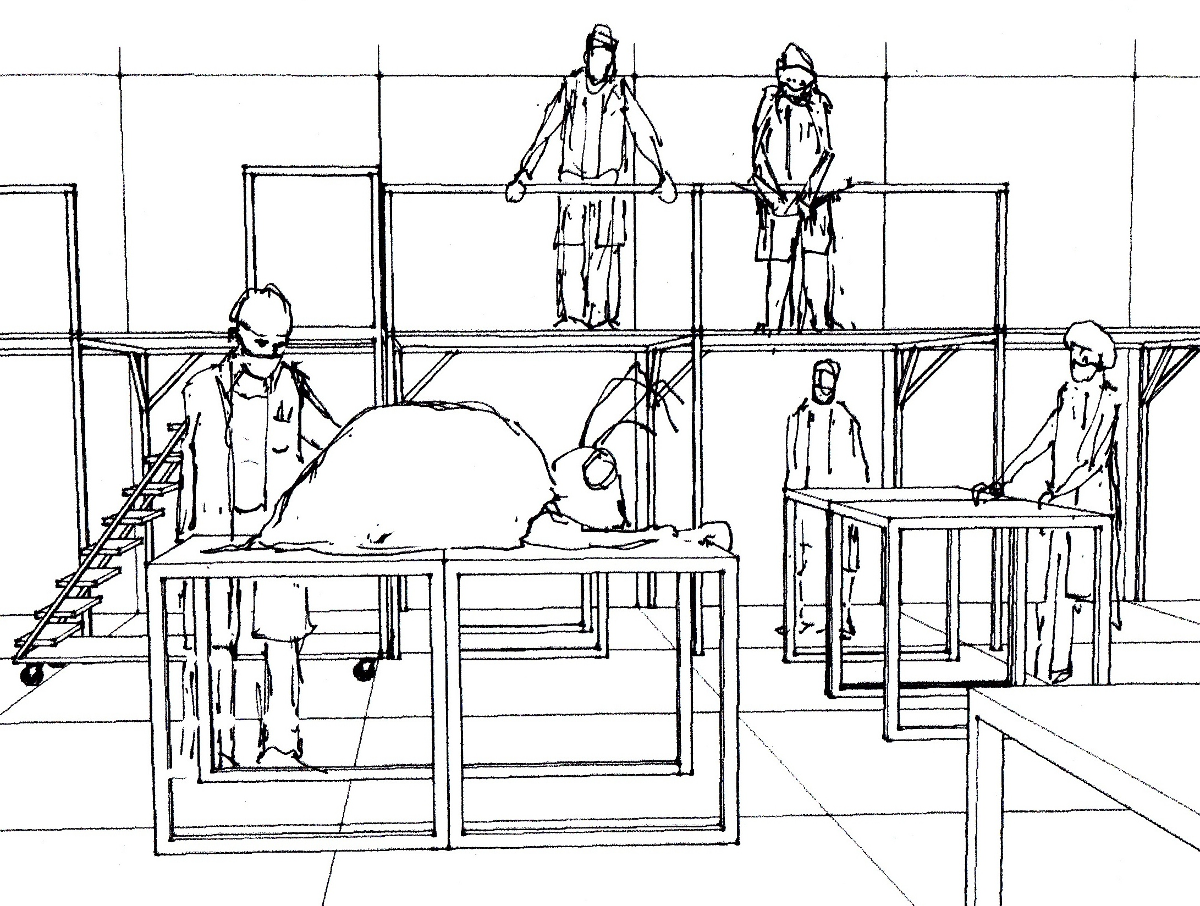

“I absorbed Goethe’s ballad [Der Erlkönig], with all its metaphysics, at age eight.
Through the half-understood German I caught, or divined, the meaning, and cried,
shaken to the bottom of my soul, when my mother read to me.”
Bruno Schulz, 1935 essay

- the ballad (part 2) -

Adela:

Shall I tell you a story? [Spring, Ch. 17, p. 167-171]

What is this map?
I touch the tree roots
I will tell you the story

A man walks under the milky stars
Wer reitet so spät durch Nacht und Wind?
folding a child in his cloak
Es ist der Vater mit seinem Kind;
he walks across the sky
he walks on and on
Er hat den Knaben wohl in dem Arm
time repeats
time can never change anything
‘it’s only the wind…’
he soothes the little boy
Er faßt ihn sicher, er hält ihn warm.
endlessly [Goethe, Erlkönig]
without hope
helplessly
helpless against the whispers and
sweet persuasions of the night.

IV. The Tree of Codes
- the secret backstage area -

Son:
human dreams; rubbish heaps
abundant, ephemeral
sudden and splendid
only to wilt and perish. [59]
Adela/ the company of actors & musicians:
I was homeless
But slowly, the world began to set traps: Overlooked beyond time
the taste of food, Time rising and falling
the patch of sunlight on the floor, expanded into tongues
the movement of limbs, into dreams
I accepted the experiment of life
I submitted to the frenzy
the scraping danger
I endured the urge to joy [65/66]

Something stirred in me
The feeling of no permanence in
life transformed
into an attempt at wonder. [67]

Adela (to the Son)
Come, take my hand
dip your face into that dusk.
under the lid of a coffin.
[Spring, Ch.17]

Open eyelids of time
a spring dusk of visions and resurrections
a thousand kaleidoscopic possibilities
with a small quick heartbeat [64]

I saw on the far side of living [83]
desperately knocking against
the blind little world
I loosened a plank [68]

I shall never forget that luminous journey
The air shimmered, trembling.
The air pulsated
with a secret spring. [84-85]
touch the tree roots
taste the sweetness

“Why did you not tell me?” [85] tell me
the last secret of the tree of codes: the last secret
nothing reaches a definite conclusion. [95]
Reality is only as thin as paper [92, Crocodiles, p.73]
behind the screen
sawdust in an empty theatre. [93]
there we feel possibilities
shaken by the nearness of realization [95]
I wanted a night that would not end [86]

_____________________________________________________________________________________________________

References:

Jonathan Safran Foer, Tree of Codes. Visual Editions, London, 2010.
Michel Foucault, Madness and Civilisation: A History of Insanity in the Age of Reason. transl. of abridged version by Richard Howard. Vintage, New York, 1988.
Johann Wolfgang von Goethe. Selected Poems. ed. Christopher Middleton, Suhrkamp/Insel, Boston, 1983.
Bruno Schultz. The Street of Crocodiles. transl. Celina Wieniewska. Penguin, London, 1977.
Bruno Schultz et al. Letters and Drawings of Bruno Schulz. Fromm, New York, 1990.

All images in the libretto are drawings of the opera costume and set design by Massimo Furlan.

